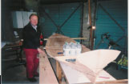 | 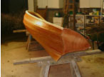 |  | 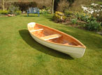
Boat during construction | Boat before painting |  | Boat almost complete
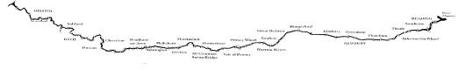

Location of locks along the route of K&A Canal
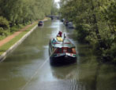 |  |  | 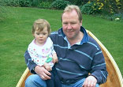
Kennet & Avon Canal |  |  | Neil & Alicia
If you would like any further information about the row or GOSH, please call me on 01306 730685
or visit our website www.RowAlicia.co.uk

SPONSORSHIP FORM
Please make cheques payable to Great Ormond Street Hospital Children’s Charity and send to Neil Warren,
5 St Martha’s Cottages, Hoe Lane, Peaslake, Surrey, GU5 9SL. If you would like GOSHCC to reclaim tax on this
donation, please complete this form and send it with your cheque.

Name………………………………………………………………………………………………………………

Address…………………………………………………………………………………………………………….

…………………………………………………………………………………………………………………….

Donation …………………………………………………. Date…………………………………………………

Signature
…………………………………………………

Great Ormond Street Hospital Children’s Charity, Registered Charity No 235825 © 1989 GOSHCC

